



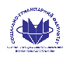

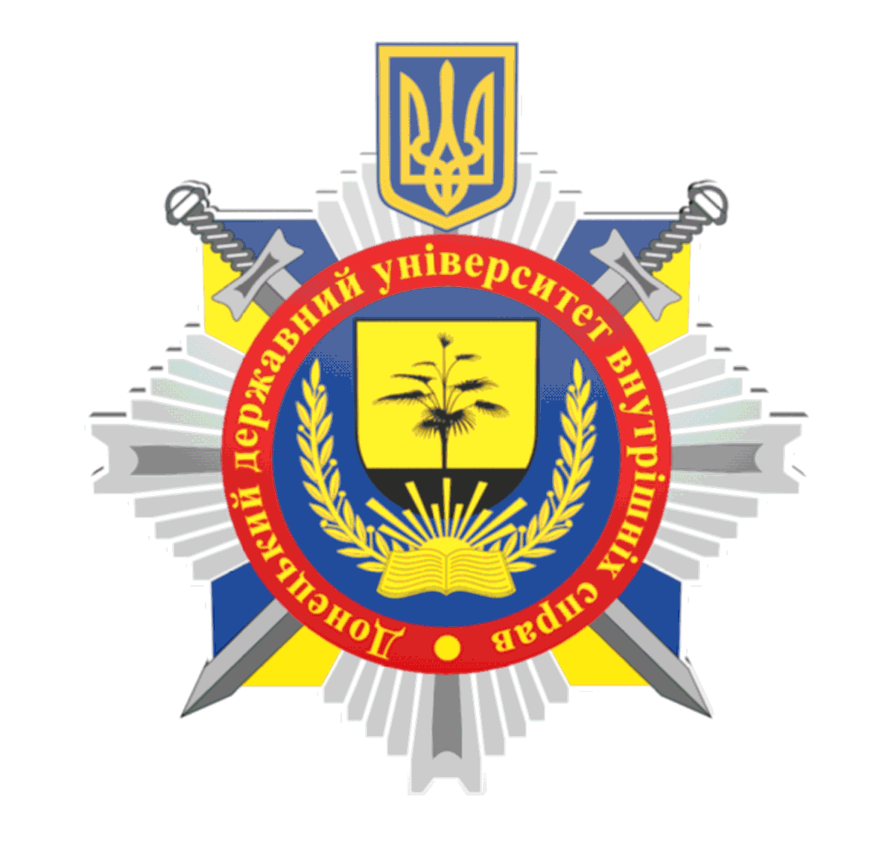
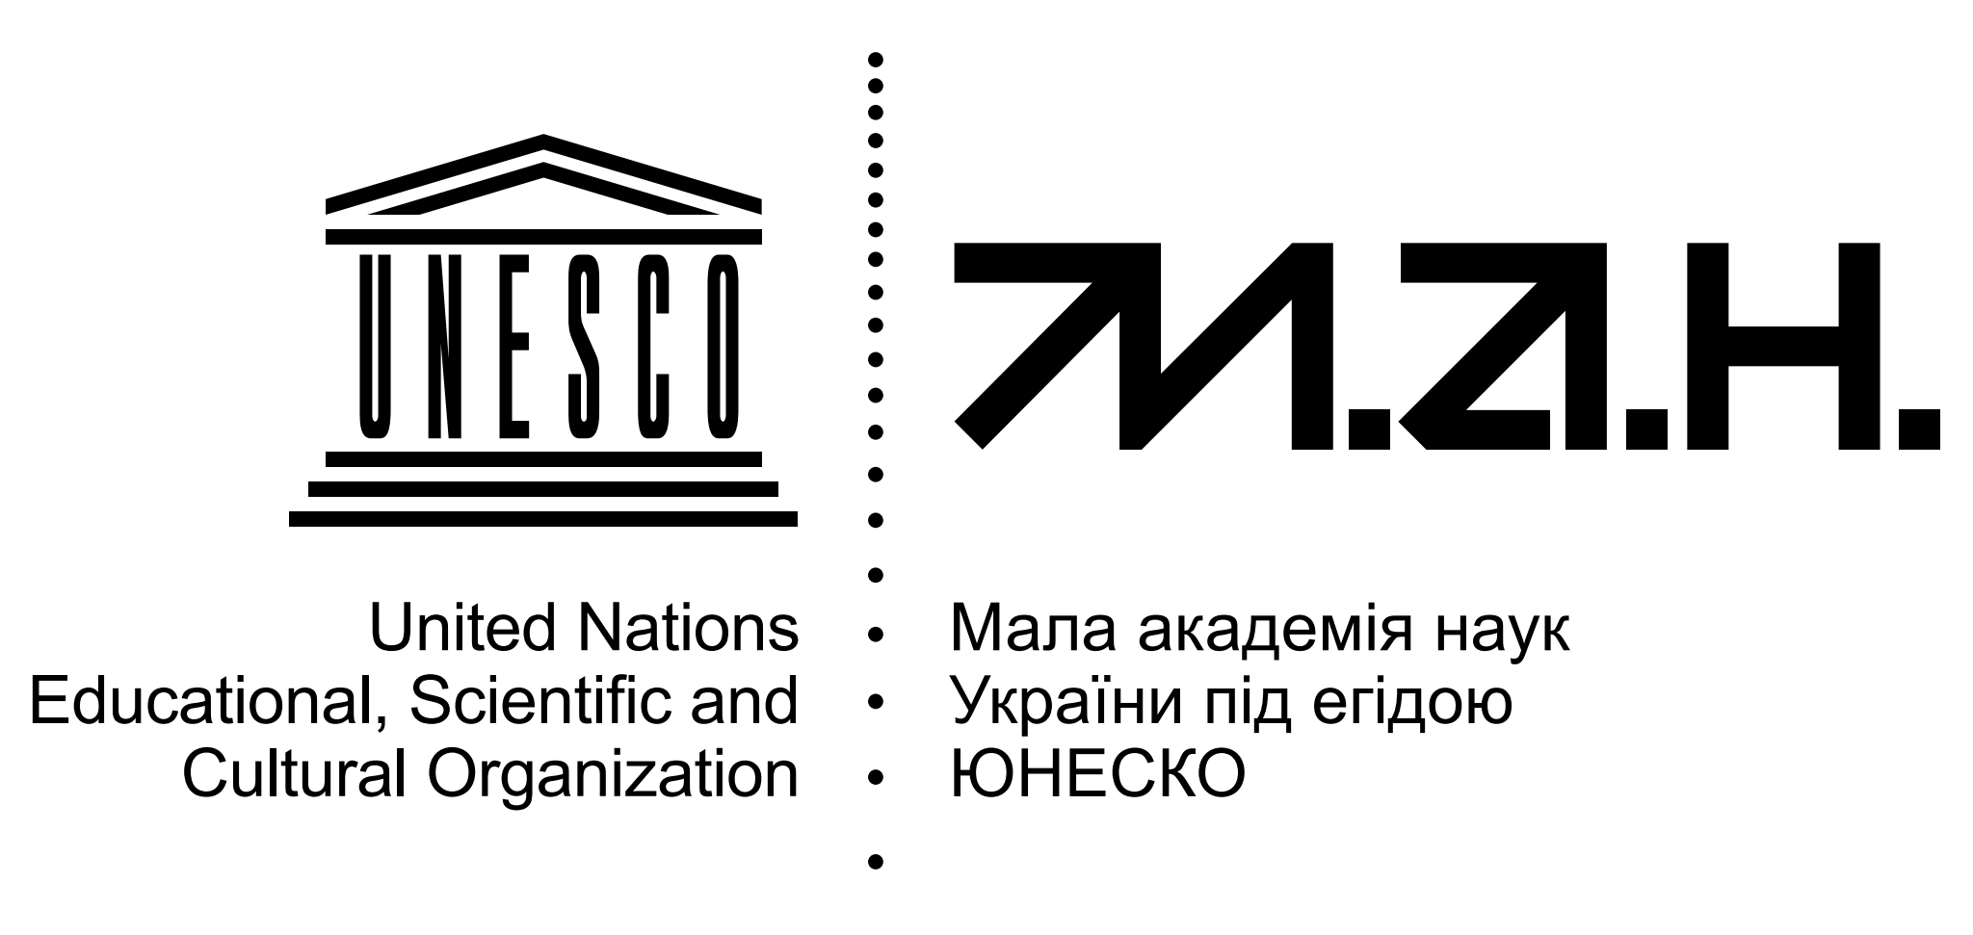







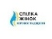





Dear scientists, educators, innovators!
Donetsk State University of Internal Affairs
invites you to participate in the IV International Scientific and Practical Internet Conference «Current Aspects of STEAM Education Development in the Context of European Integration»

The purpose of the conference is to discuss current issues related to the implementation of STEAM-technologies in the educational process of educational institutions of various levels and profiles.

Audience: scientists, teachers, graduate students, doctoral students, candidates for scientific degrees, managers, and higher education seekers who promote the dissemination of ideas for the development of STEAM-education.

AREAS OF WORK:  - global experience and prospects for the development of teaching academic disciplines in the context of STEAM education principles;  - STEAM teaching technologies in higher education institutions;  - theoretical and methodological aspects of soft skills development in the learning process of students in educational institutions;  - using educational platforms to organize international STEAM project and research activities;  - communication in the field of gender issues in the context of STEAM;  - ensuring the quality of higher education in the context of global prospects for the formation of an innovative European space. |  April 23, 2026  from 10:00 a.m. to 1:00 p.m.    Kropyvnytskyi,  1 Velyka Perspektyvna Street  Registration for conference participants is open until April 13, 2026, inclusive, at the following link:  https://dnuvs.eas.ua/#Registration  Working languages of the conference:  Ukrainian, English, Polish.
CONTACT INFORMATION:   +38097 722 05 88 (Olha KUZMENKO)   Kuzimenko12@gmail.com |   PARTICIPATION IN THE CONFERENCE IS FREE OF CHARGE!

Requirements for the abstract:

1. Typed in Word 2003, 2007, 2010; saved in .doc format in Ukrainian, English, or Polish.
2. Font type – Times New Roman; font size – 14; line spacing – 1.5.
3. A4 format; margins: left – 30 mm; right – 20 mm; top and bottom – 25 mm; paragraph indentation – 10 mm.
4. Highlighting types – bold, italics, bold italics.
5. Copies of tables, diagrams, and figures (electronic version required) must be saved as separate files.
6. Figures should be created in Microsoft Word. Scanned figures should have a resolution of at least 300 dpi.
7. Abstracts up to 3 pages in length should be formatted according to the template.

Please send abstracts to the following email address by April 13, 2026: Kuzimenko12@gmail.com

Sample format for abstracts

Olha Kuzmenko
Scientific Secretary of the Academic Council Secretariat
Donetsk State University of Internal Affairs
Kropyvnytskyi, Ukraine
D.Sc. in Pedagogy, Professor

THEORETICAL AND PRACTICAL ASPECTS OF STEAM-EDUCATION DEVELOPMENT IN THE CONTEXT OF GENDER EQUALITY IN HIGHER EDUCATION INSTITUTIONS

text of the report abstract…….

List of sources (12 points)

is prepared in accordance with the National Standard of Ukraine DSTU 8302:2015 “Information and documentation. Bibliographic references. General provisions and rules for compilation.”
At the end of the conference, authors will receive a certificate and an electronic collection of abstracts.

Please note!
The authors are responsible for the accuracy of the information provided and the originality of the text.
In case of incorrectly formatted abstracts, plagiarism, or self-plagiarism, the organizing committee has the right to remove materials from consideration and printing in the conference proceedings.

